





Account Registration Instructions

For Consultants & Preparers

Iowa Department of Natural Resources
Air Quality Bureau
6200 Park Ave Ste 200
Des Moines, IA 50321

Contact the Iowa EASY Air Help Desk
email: easyair@dnr.iowa.gov
Or call (515) 725-9569 or (515) 725-9547

Table of Contents

1. Iowa EASY Air Website Login 3
2. Self-Registration 4
2.1 Fill in General Information 4
2.2 Indicate Account Type 5
2.3 Select and answer Security Questions 6
2.4 Pass Picture Verification 7
2.5 Account Created Confirmation 7
2.6 Receive email confirmation from Iowa EASY Air 8
3. Access Your Account Information 8

List of Figures

Figure 1 - Iowa EASY Air Website Login Page 3
Figure 2 - Access Self – Registration 4
Figure 3 - Fill in General Information 4
Figure 4 - Select Account and Submittal Groups 5
Figure 5 - Security Questions 6
Figure 6 - Picture Verification 7
Figure 7 - Account Confirmation 7
Figure 8 - Account Confirmation Email 8
Figure 9 - Access “My Account” 8
Figure 10 - Access “My Account - Responsible Officials” 9

To access Iowa DNR’s Environmental Application System for Air (Iowa EASY Air), users must first register and then log into the system to complete their account. This document explains how to register as a Consultant / Preparer in Iowa EASY Air, sign into the system, and access your account information.

Iowa EASY Air Website Login
Use a reliable Internet connection and a current web browser (e.g. Edge, Chrome, Firefox, Safari, Opera IE 11, etc.) to access the login page of the Iowa EASY Air website. When the screen shown in Figure 1 appears, you will need to determine if you need a new account or if you already have an account.
Obtaining a User Name and password requires self-registering for the system. Make note of the bottom check marked section (circled in red) before creating a new account, as you may already have a migrated account.
This document covers the steps to take for a new user to set up a new account.
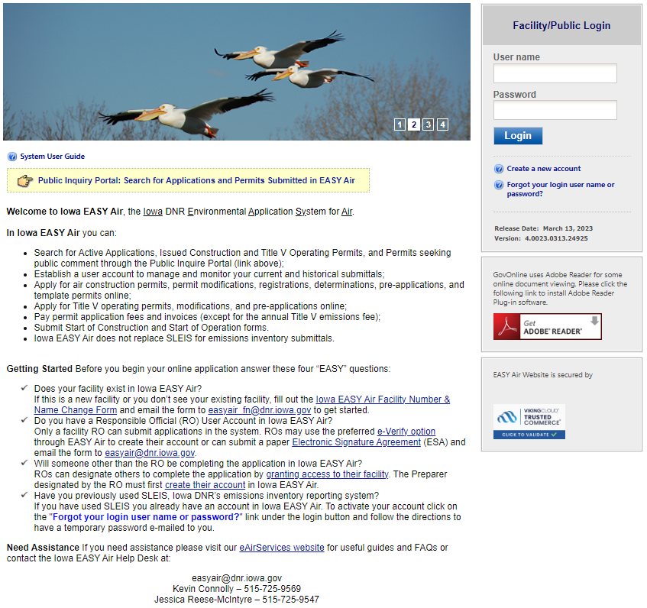
If you had a SLEIS account prior to November 2019, your information was migrated into an Iowa EASY Air account. If you did not have a SLEIS account, you will need to create a new Iowa EASY Air account.
Figure 1 - Iowa EASY Air Website Login Page

Self-Registration
Click on “Create a new account” (Figure 2). Follow instructions 2.1 – 2.7 to register.
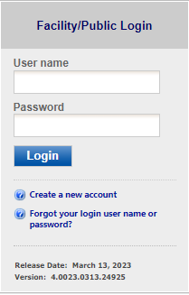
Figure 2 - Access Self – Registration

Fill in General Information
The registrant needs to complete all required fields in Figure 3 (denoted with a red asterisk icon). The suggested UserName may be modified at this step. If you wish to receive text messages from the system, enter a mobile phone number and select your cellular provider (If your provider is not listed, please notify the Help Desk). When finished, click the blue “Next>>” button.

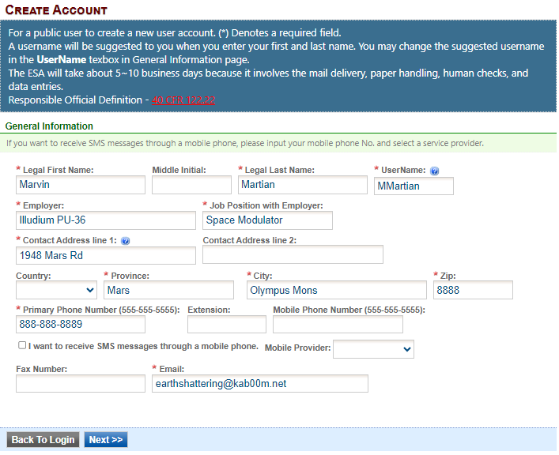
Figure 3 - Fill in General Information

Indicate Account Type
There are two user account types having different roles. An explanation of each of these roles is provided below (Table 1). The RO user role has additional privileges above the level of the Preparer.
Table 1 - Account Types in Iowa EASY Air
User Type | Account Privileges
Responsible Official (RO) | - Will create a PIN once their account privileges are approved by IOWA DNR  - Certify and submit an electronic data entry form in Iowa EASY Air  - Manage Preparers and Consultants  - View and prepare an electronic data entry form in Iowa EASY Air  - View submitted data in Iowa EASY Air  - Keep track of the status of submitted records
Preparer | - View and prepare an electronic data entry form in Iowa EASY Air  - View submitted data in Iowa EASY Air  - Keep track of the status of submitted records

If you are uncertain as to which role applies to you, contact the EASY Air Helpdesk at (515) 725-9569 or (515) 725-9547; or send your inquiry to easyair@dnr.iowa.gov.

Unless you will be submitting Permit Applications, choose the “Preparer” user account type (Figure 4). Select the “Preparer” Submittal Group. Then select the “Next>>” button to proceed.

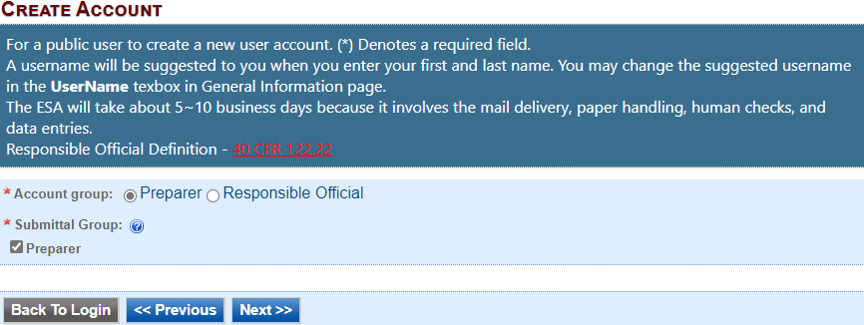
Figure 4 - Select Account and Submittal Groups

Click the blue “Next>>” button to continue the registration process in Section 2.3.

Select and answer Security Questions
The RO must assign answers to five security questions (Figure 5). These are required as part of the Certification process to Notify the Responsible Official that a permit application is ready for review and submittal through Iowa EASY Air. The questions and answers may be changed in the user's profile page within EASY Air in Figure 9.
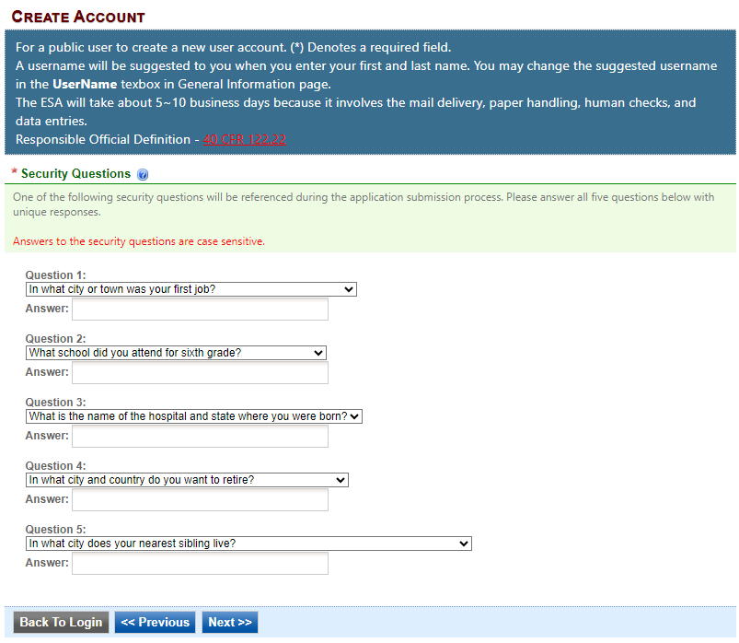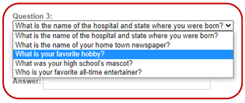
Figure 5 - Security Questions

There are 5 questions in the 5 question groups (see insert, Figure 5). Choose questions and answers that are easy for you to remember but difficult for others to guess. Click on the blue “Next>>” button when complete.

Pass Picture Verification
Enter the characters you see in Figure 6 (case sensitive) into the highlighted field. The characters are drawn so that it is possible for a person to recognize them, but very difficult for a program to. This helps us prevent automated programs from creating large numbers of accounts and sending spam. Use the recycle button to have a new verification picture generated if the original picture is unclear. Click on “Create Account” button.

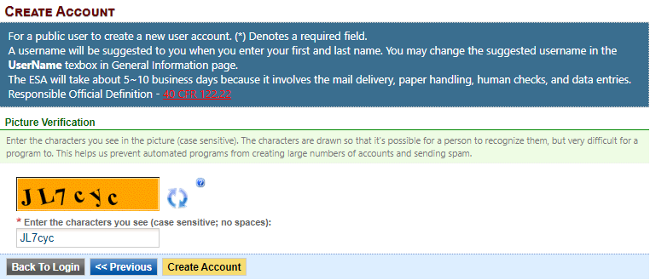
Figure 6 - Picture Verification

Account Created Confirmation
Congratulations your account has been created. Refer to Item 2 in the confirmation window below. Notify your Responsible Official that your account is ready to be associated to create and prepare Iowa EASY Air permit applications.

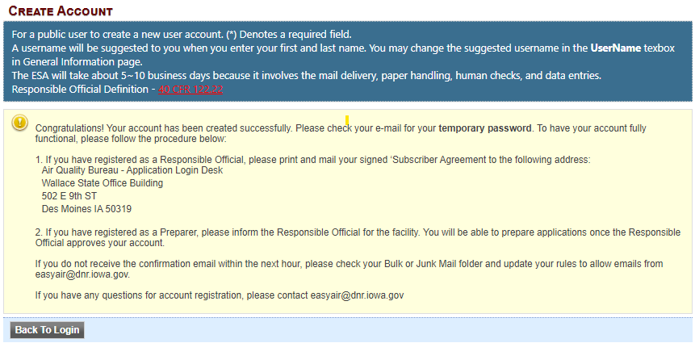
Figure 7 - Account Confirmation
You will receive an email with a temporary password to log in to EASY Air. Click the "Back To Login" button to enter your username and temporary password (see Section 2.6).

Receive email confirmation from Iowa EASY Air
Soon after you have successfully registered, you will receive an e-mail (Figure 8) from Iowa DNR that includes your Iowa EASY Air temporary password. This user ID and password are used one time to log into the Iowa EASY Air system for the first time.
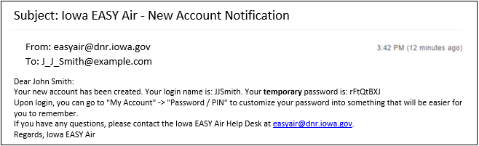
Figure 8 - Account Confirmation Email

Access Your Account Information
To view or make changes to your account information, log into Iowa EASY AIR (see Figure 1). Then click on the “My Account” tab (Figure 9). This page should be used to keep your Iowa EASY AIR account information up-to-date and change your password and manage your security questions.
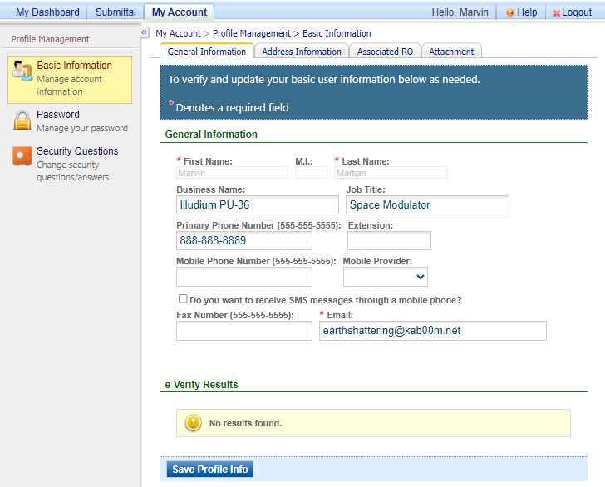
Figure 9 - Access “My Account”

Clicking on the "Associated RO" tab will show the Preparer's association to one or more Responsible Officials, the facilities and permit application types assigned by each Responsible Official. This shows the RO Name, the Facility, the Permission for each Submittal Type, the Effective Start Date when access was approved, an Expiration Date (if set by the RO) and the Status of access for each Application Type.
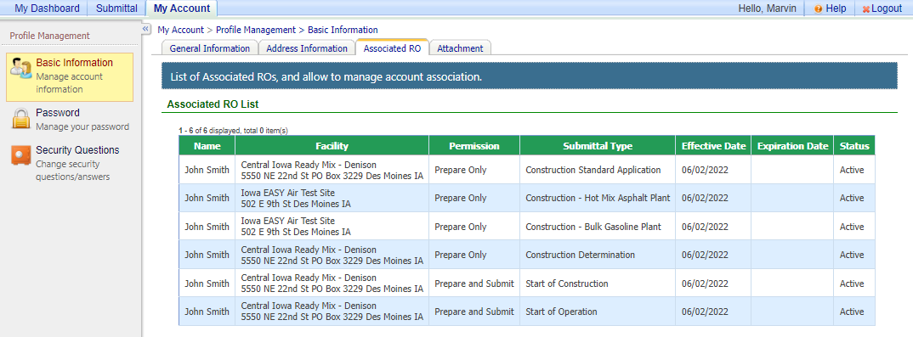
Figure 10 - Access “My Account - Responsible Officials”

If you have questions, please contact the Iowa EASY Air Help Desk
by sending an email to easyair@dnr.iowa.gov.
Or, call (515) 725-9569 or (515) 725-9547

